“Київський фаховий коледж зв’язку”

Циклова комісія комп’ютерної та програмної інженерії

**ЗВІТ ПО ВИКОНАННЮ**

**ЛАБОРАТОРНОЇ РОБОТИ №8**  
з дисципліни: «Операційні системи»  
Тема: “Збереження службових даних системи та її мережева конфігурація”

Виконали студенти

групи БІКС-13

Команда JRSY: Андрущик П.С   
Бурбан Д.Ю.  
Перевірив викладач

Сушанова В.С.

Київ 2024

**The goal of the work: (робила студентка Андрущик Поліна)**-Getting hands-on skills with the Bash command line program.  
-Familiarity with the basic structures for saving system data - processes, memory, log files and kernel status messages.  
-Familiarity with the FHS standard.  
-Acquaintance with network configuration actions.  
  
**1. *Read the short theoretical information for the laboratory work and make a small dictionary of basic English terms for the assignment of commands and their parameters.**

|  |  |
| --- | --- |
| **Term in English** | **Term in Ukrainian** |
| Network | Мережа — це сукупність двох або більше хостів (комп’ютерів), які можуть спілкуватися один з одним. Цей зв’язок може здійснюватися через дротове або бездротове з’єднання. |
| Internet | Прикладом мережі є Інтернет. Він складається з загальнодоступної мережі, яка з’єднує мільйони хостів по всьому світу. Багато людей використовують Інтернет для перегляду веб-сторінок і обміну електронними листами, але Інтернет має багато додаткових можливостей, крім цих видів діяльності. |
| Wi-Fi | Термін Wi-Fi відноситься до бездротових мереж. |
| Server | Хост, який надає послугу іншому хосту або клієнту, називається сервером. Наприклад, веб-сервер зберігає, обробляє та доставляє веб-сторінки. Сервер електронної пошти отримує вхідну пошту та доставляє вихідну пошту. |
| Client | Клієнт - це хост, який звертається до сервера. Коли ви працюєте за комп’ютером і переглядаєте Інтернет, ви вважається клієнтським хостом. |

**2. On the basis of the considered material, answer the following questions:  
Explain the concept of "pseudo file system", why does the system need it?  
-** A pseudo-file system is an abstraction layer that allows applications and users to work with a variety of data sources, such as I/O devices or network resources, through a file system interface, simplifying interactions and providing uniform access to that data across the system.

**Why don't users go directly to the /proc directory so often, how can you get information from it?  
-** Users do not often access the /proc directory directly because it contains a large amount of system information that can be difficult to understand and requires special commands and tools to extract information from it. Information can be obtained from the /proc directory by reading the contents of text files that represent system parameters, process status, hardware information, and more, using terminal commands or programs that interact with the file system.

**\*What is the purpose of the files /proc/cmdline, /proc/meminfo and /proc/modules?  
-** The /proc/cmdline file contains the command-line options that were passed to the Linux kernel when it started; /proc/meminfo contains information about system memory usage; /proc/modules contains a list of loaded Linux kernel modules.

**\*What is the purpose of the free command?  
-** The "free" command is used to display information about free and used RAM on a Linux system.

**\*Why are log files needed, give examples of their use?  
-** Log files are used to record events, errors and information about the execution of programs or systems, which allows you to analyze their operation, identify problems and improve their efficiency. For example, in web development, log files help track requests, server errors, and identify potential security threats.

**\*\*What is the purpose of the /var/log/dmesg file?  
-** The /var/log/dmesg file contains the system's kernel startup log, which contains information about hardware diagnostics and other messages generated by the kernel during system boot.

**\*\*What is FHS designed for?  
-** FHS (Filesystem Hierarchy Standard) is designed to standardize the structure of directories and files in UNIX-like operating systems, providing uniformity in the location of system and user files to facilitate management and software development.

**\*\*What are the basic commands in Linux for network viewing and configuration  
-** Basic commands in Linux for viewing and configuring a network include `ifconfig` for viewing information about network interfaces, `ip` for more advanced network management, `route` for viewing the routing table, and `ping` for checking the reachability of hosts.  
  
**The main positions of the course of work: (робив студент Бурбан Данило)  
Answers to control questions:**

1. **Initial work in CLI mode in Linux OS of the Linux family:**

**Start the VirtualBox virtual machine, select CentOS and run it. Log in to the system as user: CentOS, password for login: reverse (if you run LR in 401 aud.) and launch the terminal.**

**Start the Ubuntu_PC virtual machine (if you are doing the LR tasks through the netacad academy)**

**Start your Linux operating system (if you're on your own PC and have it installed) and launch a terminal.**

1. **Work through all the example commands presented in the labs of the NDG Linux Essentials course - Lab 13: Where Data is Stored and Lab 14: Network Configuration. Create a table to describe these commands**

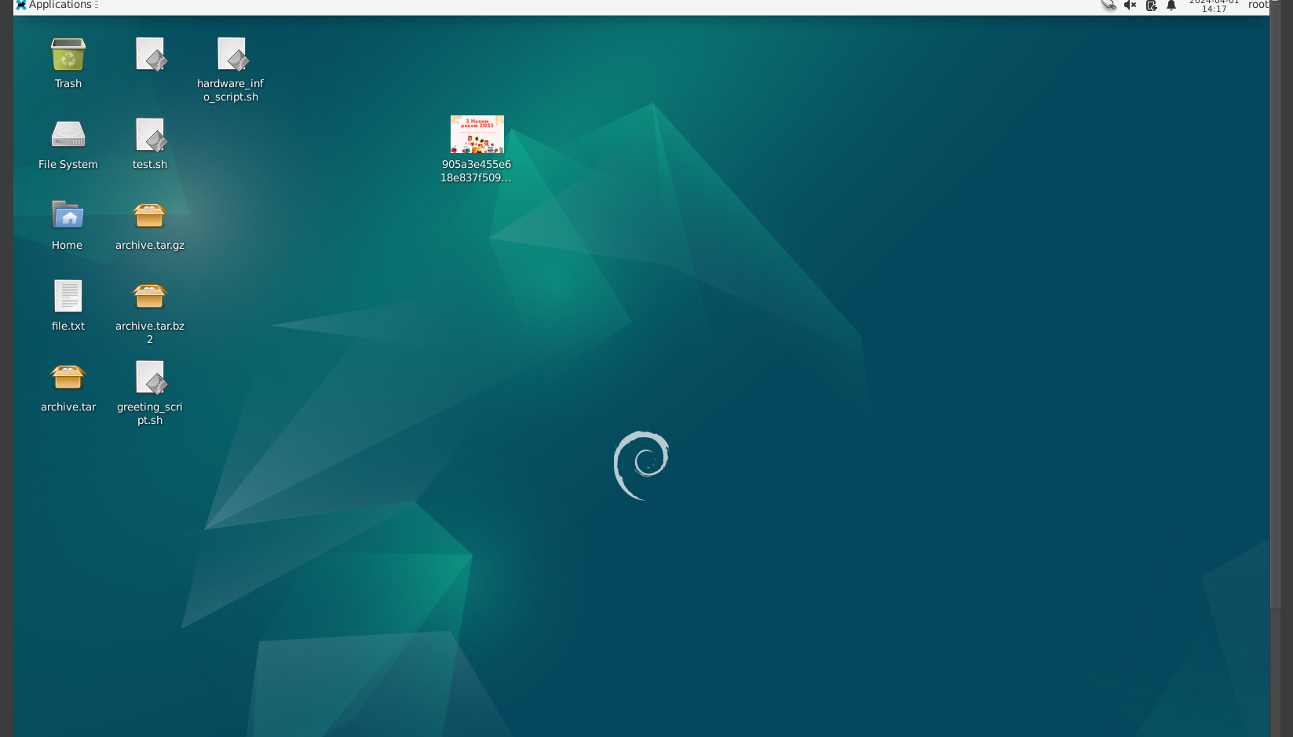

| Command | Description |
| --- | --- |
| su | We change the current user to root |
| ls /proc | View the contents of the /proc system directory (root access rights are required for this) |
| ifdown eth0 | Shut down the network interface eth0 |
| service | Manage system services |
| ifconfig | Display information about network interfaces |
| route | Display and configure routing table |
| ping | Check the availability of a network device or host in the network |
| netstat | Display status of network connections, routes, interfaces, etc. |
| ss | Display information about network sockets |
| dig | Perform DNS queries |
| host | Perform DNS queries |
| exit | Exit the current shell or session |
| ssh | Connect to a remote server using SSH protocol |
| top | Display list of processes using CPU resources |
| free | Display information about free and used memory |
| mount | Mount file systems onto the directory tree |
| umount | Unmount mounted file systems |
| pstree | Display list of processes in a tree-like format |
| ps | Display information about processes |
| pstree | Display list of processes in a tree-like format |
| ps aux | Display detailed information about all user processes |
| head | Output the first few lines of a file or output |
| less | View text output one screenful at a time |
| dmesg | Display system logs |
| rpm -ql package_name | Display list of files belonging to the installed package |

1. **Complete practical tasks in the terminal (show screenshots):**

in this laboratory work, the cat command was used, examine its capabilities and describe what tasks it is intended for;

*demonstrate examples when the cat command is used to create a file, view the contents of a file, redirect information to another file, glue several files into one;

*what parameters of the cat command should be used to number the lines of the file, display non-printing characters, remove empty lines?

**describe the capabilities of the dig command and give examples;

**describe the capabilities of the netstat command and give examples;.

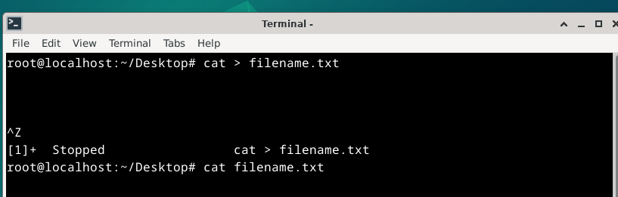

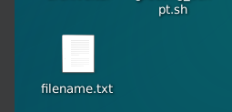

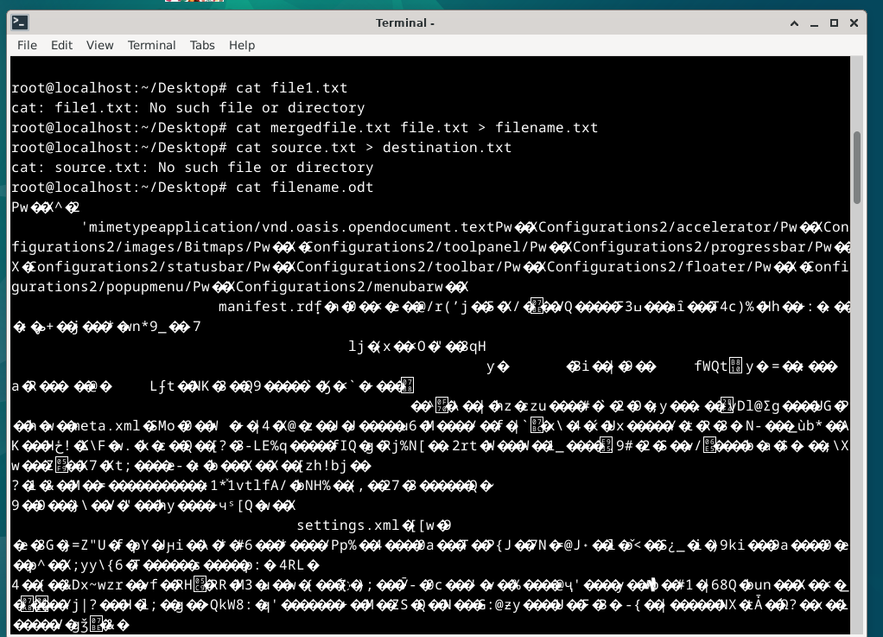

**dig example.com # Perform DNS queries for the example.com domain**

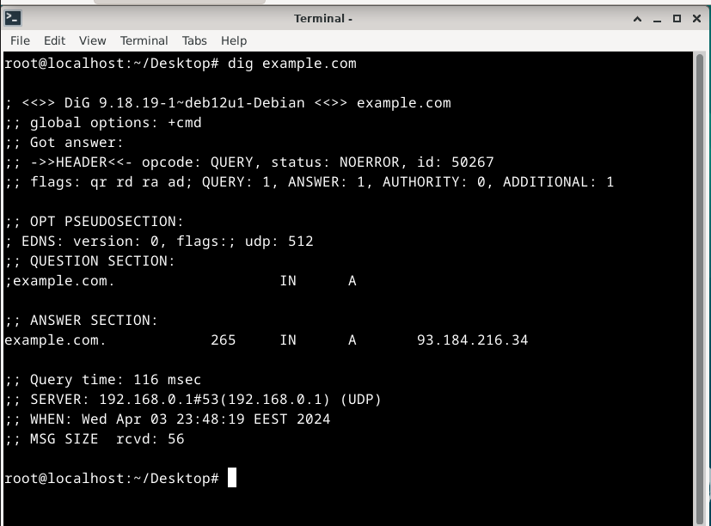

**dig -t MX example.com # Display the MX records for the example.com domain**

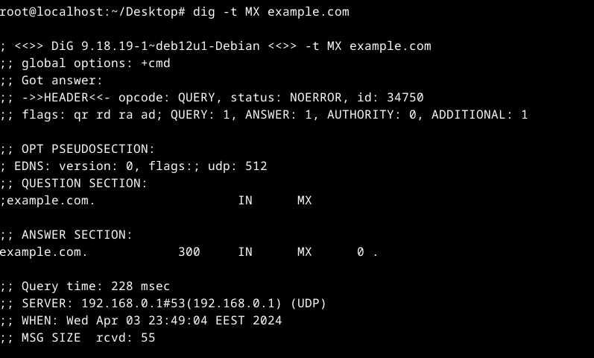

**dig @8.8.8.8 example.com # Make DNS queries to a specific DNS server**

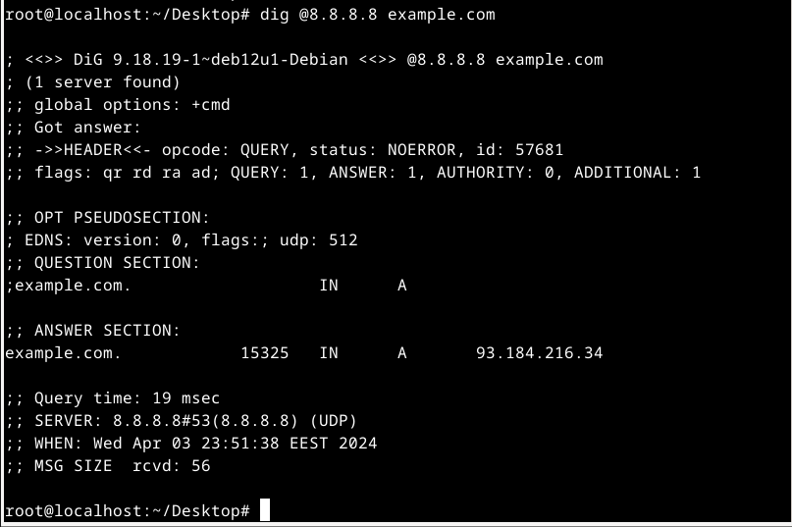

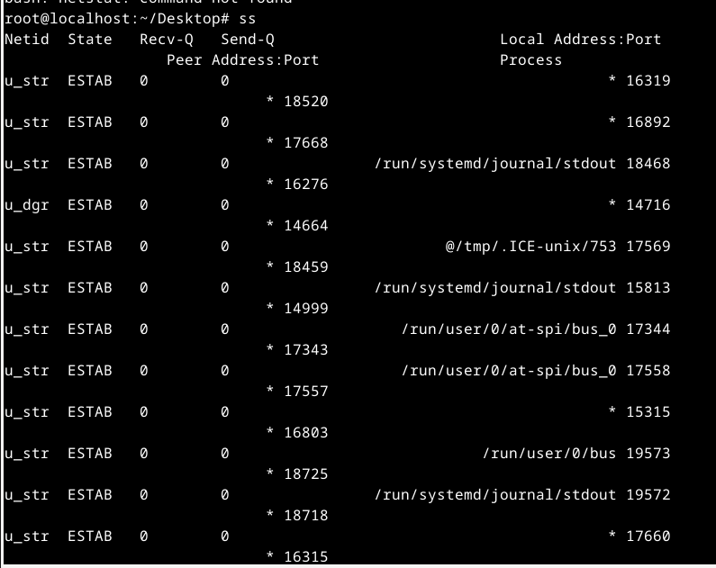

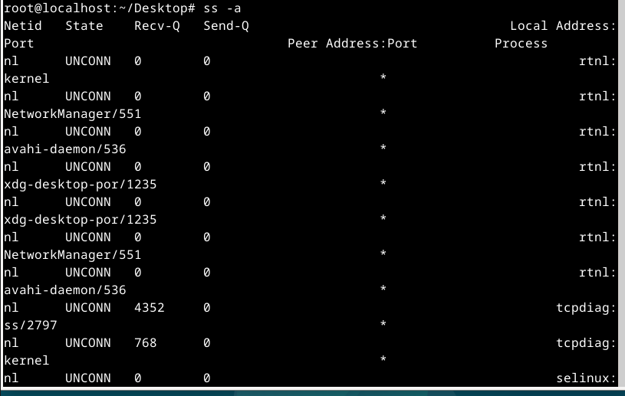

**Control questions:**

1. **How are cat and tac commands related?**

cat and tac are both commands used for manipulating text files. While cat displays the content of a file in forward order, tac does the opposite - it displays the content in reverse order, line by line. Essentially, tac is cat spelled backward.

1. **What does the ss team do?**

The ss command (Socket Statistics) is used to display information about active sockets on a system. It provides similar functionality to netstat, but with more options and better performance.

1. **What is the difference between the ps --forest and pstree commands?**

Both ps --forest and pstree commands display processes in a tree-like structure, but they use different methods to generate this structure. ps --forest is an option of the ps command which displays processes in a hierarchical tree structure based on their parent-child relationships. pstree is a separate command that also displays processes in a tree-like format, but it gathers information from the system's process table and presents it in a visual tree format.

1. **In which directories are system settings stored?**

System settings are typically stored in directories such as /etc (configuration files), /usr/share (shared system configuration/data), and /var (variable data, including log files).

1. **In which directories can you find programs installed on the system and available to the user?**

Programs installed on the system and available to users are typically stored in directories such as /bin, /usr/bin, /sbin, /usr/sbin, /usr/local/bin, and /usr/local/sbin.

1. **In which directories can you find installed system programs and programs designed to be executed by the superuser?**

Programs designed to be executed by the superuser (root) are typically stored in directories such as /sbin and /usr/sbin. System programs can also be found in directories like /bin, /usr/bin, and /usr/sbin.

Explain the purpose of the ping, ifconfig, traceroute commands.

ping is used to test the reachability of a host on an IP network and to measure the round-trip time for messages sent from the originating host to a destination computer.

ifconfig (now deprecated, replaced by ip) is used to configure and display network interfaces on a system, including assigning IP addresses and enabling/disabling interfaces.

traceroute is used to track the route that packets take from a source to a destination over an IP network. It shows the IP addresses of routers along the path and the time it takes for packets to reach each router.

1. **What are network interfaces called in Linux?**

Network interfaces in Linux are often referred to as "NICs" (Network Interface Cards) or simply "interfaces."

1. **How to use the ifconfig command to display the parameters of only one network interface (for example, eth1), and not all?**

To display the parameters of a specific network interface, such as eth1, you can use the following command: **ifconfig eth1**

**Conclusions based on the results of the work:** During the laboratory work, the basic commands and methods for saving and configuring the network in the Linux operating system were studied. The work made it possible to learn important skills in using tools such as ifconfig, ip, route, ping, other utilities for network administration and saving settings in file configurations. The result of the work is an in-depth understanding of the networking aspects of the Linux operating system and the ability to effectively manage network configuration and save system service data for later use.